Appendix C: Cell Phone Waiting Lot Information

DEN Cell Phone Lot EV Spaces:
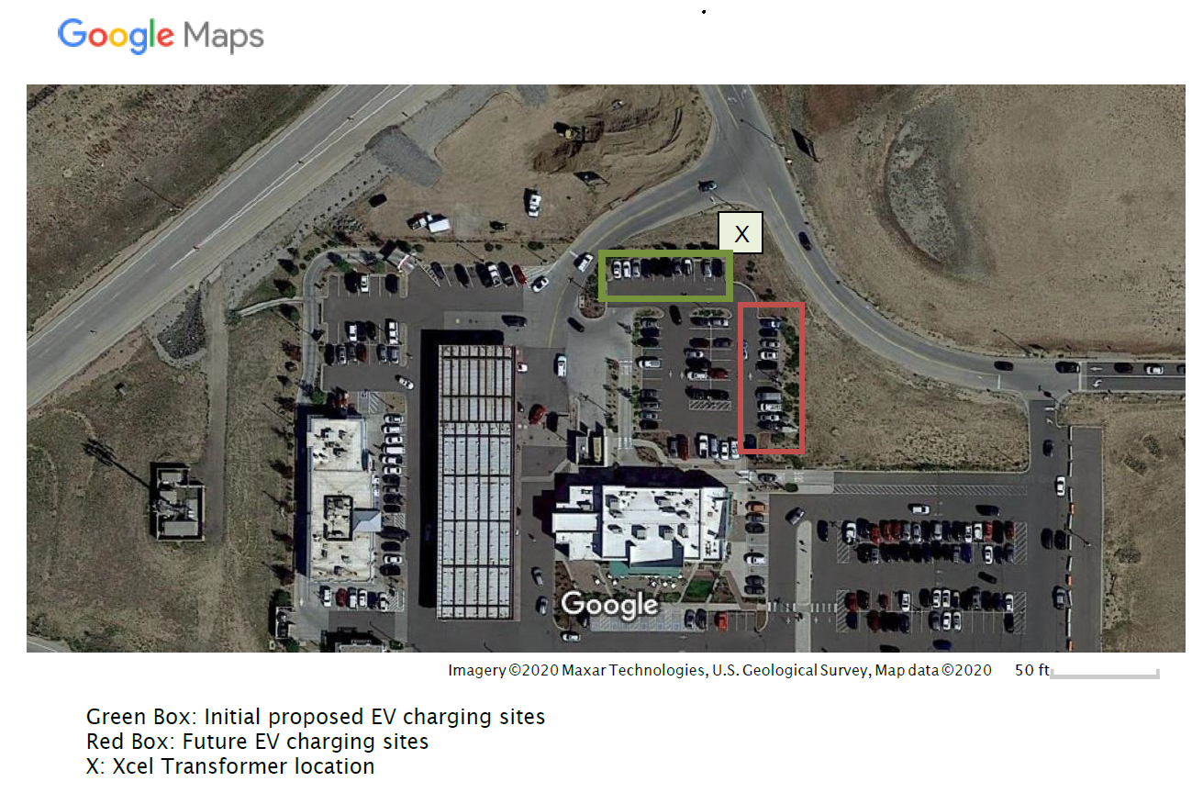
DEN Cell Phone Lot Map with Utilities:
